CITY OF SIGNAL HILL
FIRST AMENDMENT TO
AGREEMENT FOR ON-CALL ENVIRONMENTAL EMERGENCY RESPONSE SERVICES
- Parties and Date.
This First Amendment to the Agreement for On-Call Environmental Emergency Response Services (“First Amendment”) is entered into on the 14th day of January, 2025, by and between the City of Signal Hill, a municipal corporation, organized under the laws of the State of California, with its principal place of business at 2175 Cherry Avenue Signal Hill, CA 90755 (“City”) and Ocean Blue Environmental Services, Inc., a California Corporation, with its principal place of business at 925 West Esther Street, Long Beach, CA 90813 (“Contractor”). City and Contractor are sometimes individually referred to herein as “Party” and collectively as “Parties.”
- Recitals.
  - Agreement. The Parties entered into that certain Agreement for On-Call Environmental Emergency Services dated January 11, 2022, for a term of three years, expiring on January 11, 2025, and a total compensation not-to-exceed $92,269 (“Agreement”).
  - First Amendment. The Parties now desire to amend the Agreement in order to extend the term by one additional three-year term to expire on January 11, 2028, update the rates of compensation under the Agreement and to increase the total compensation under the Agreement to $191,634 (“First Amendment).
- Terms.
  - Term. Section 3.1.2 of the Agreement is hereby amended in its entirety to read as follows:
“The term of this Agreement shall be from January 11, 2022, to January 11, 2028, unless earlier terminated as provided herein. At the City’s sole discretion, the term may be extended administratively by up to 180 calendar days with the approval of the City’s Director of Public Works. Contractor shall complete the Services within the term of this Agreement and shall meet any other established schedules and deadlines.”
  - Compensation. Section 3.3.1 of the Agreement is hereby amended in its entirety to read as follows:
Contractor shall receive compensation, including authorized reimbursements, for all Services rendered under this Agreement at the rates set forth in Exhibit “C” attached hereto and incorporated herein by reference. The total compensation shall not exceed One Hundred Ninety-One Thousand Six Hundred Thirty-Four DOLLARS ($191,634) without written approval of the City Council or City Manager as applicable. Extra Work may be authorized, as described below, and if authorized, will be compensated at the rates and manner set forth in this Agreement.
  - Rates of Compensation. Exhibit “C” of the Agreement is hereby amended in its entirely in the form of Attachment 1 to this First Amendment, attached hereto and incorporated herein.
  - Remaining Provisions of Agreement. Except as otherwise specifically set forth in this First Amendment, the remaining provisions of the Agreement shall remain in full force and effect.
CITY OF SIGNAL HILL | OCEAN BLUE ENVIRONMENTAL SERVICES, INC.
By:  Carlo Tomaino  City Manager | By:  [INSERT NAME AND TITLE]
 | [If Corporation, TWO SIGNATURES, President OR Vice President AND Secretary OR Treasurer REQUIRED]
ATTEST:
By:  Kim Boles  Assistant City Clerk | By:  [INSERT NAME AND TITLE]
APPROVED AS TO FORM:
By:
Matthew E. Richardson
City Attorney

ATTACHMENT “1” TO FIRST AMENDMENT TO
AGREEMENT FOR ON-CALL ENVIROMENTAL EMERGENCY RESPONSE SERVICES
Exhibit “C”

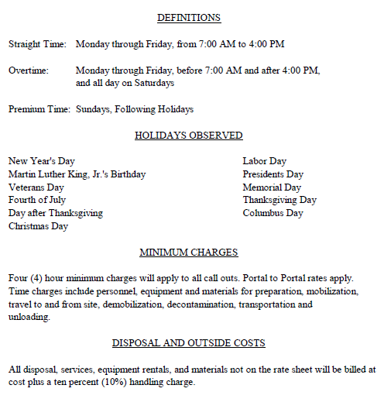

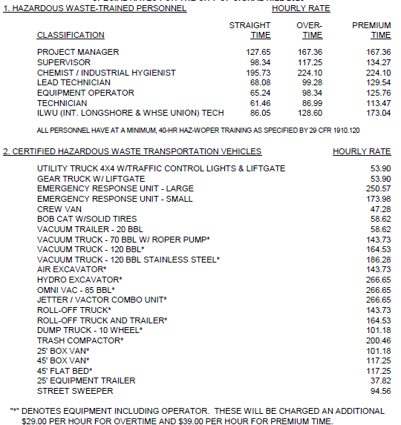

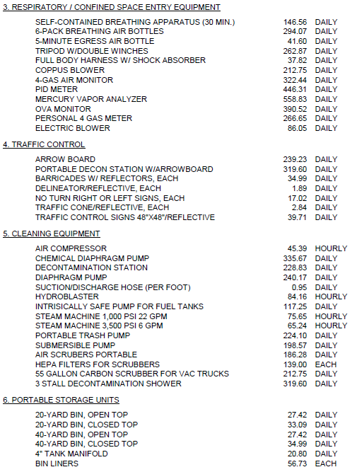
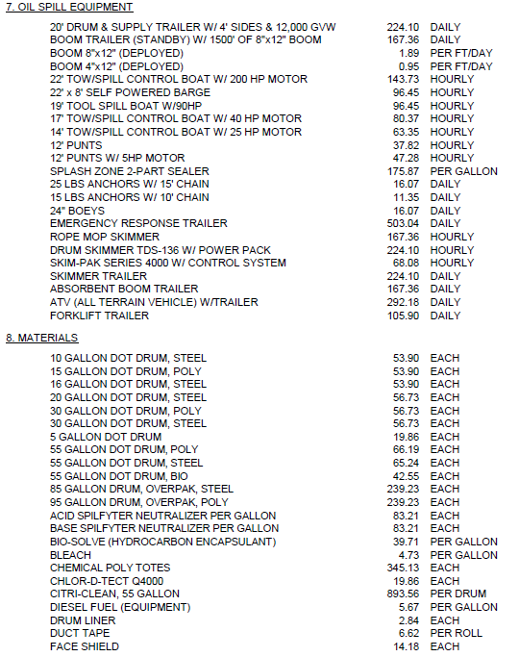
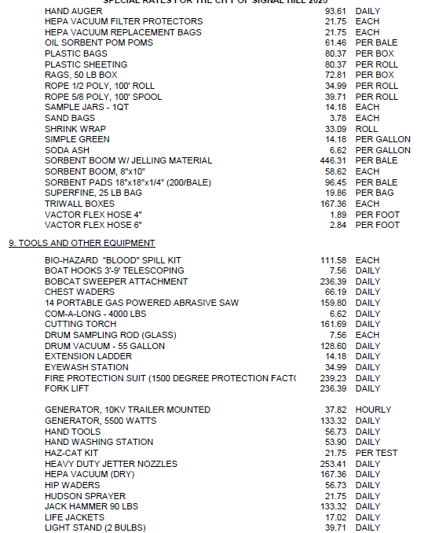
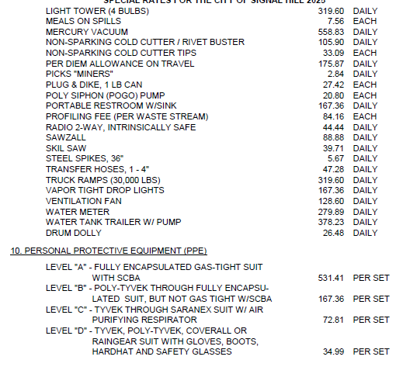

- Any work by subcontractor shall be pre-approved by the City. Contractor’s overhead and profit for work performed by the subcontractor shall not exceed 10% of actual work.

- All invoices shall include line items for all personnel describing the work performed, the number of hours worked, and the hourly rate.

- All invoices shall include line items for all materials and equipment properly charged for the services.

- All invoices shall include line items for all other approved reimbursable expenses claimed, with supporting documentation.

- Line items for all approved subcontractor labor, supplies, equipment, materials, and travel properly charged for the services.

- The total compensation over the term of the Agreement shall not exceed $191,634 as provided in Section 3.3.1 of this Agreement.

  - The maximum annual compensation for each year over the term if the Agreement shall not exceed the following:

Agreement Term | Year | Not-to-Exceed  (CPI Increase max 2.5%)
January 11, 2022 – January 11, 2023 | 1 | $30,000
January 11, 2023 – January 11, 2024 | 2 | $30,750
January 11, 2024 – January 11, 2025 | 3 | $31,519
January 12, 2025 – January 11, 2026 | 4 | $32,307
January 12, 2026 – January 11, 2027 | 5 | $33,115
January 12, 2027 – January 11, 2028 | 6 | $33,943
Total |  | $191,634

  - Contractor shall provide a Performance Bond and Payment Bond pursuant to Sections 3.2.12.1 and 3.2.12.2 of this Agreement, executed by a surety meeting the qualifications described in Section 3.2.12.4.

