City of Signal Hill

Outstanding Older American Previous Award Recipients

2000 Chuck Gerst
2001 Ted Bunten
2002 Nona Daly
2003 John Leahy
2004 Mary Justus
2005 Gary Dudley
2006 Keaton King
2007 Chan Brainard and Gil Griego
2008 Jane Fallon
2009 Hazel Wallace
2010 Gary Weinberger
2011 Frank Virga
2012 Al Sirignano
2013 Louise Cunningham
2014 George & Carol Apt
2015 Steve Strichart
2016 Neena Strichart
2017 Mildred Wallerstein
2018 Rose Richárd
2019 Larry Forester
2020 Judie Johnsen
2021 Pam Dutch Hughes
2022 Robert Long
2023 Larry Blunden
2024 Jene Bunten

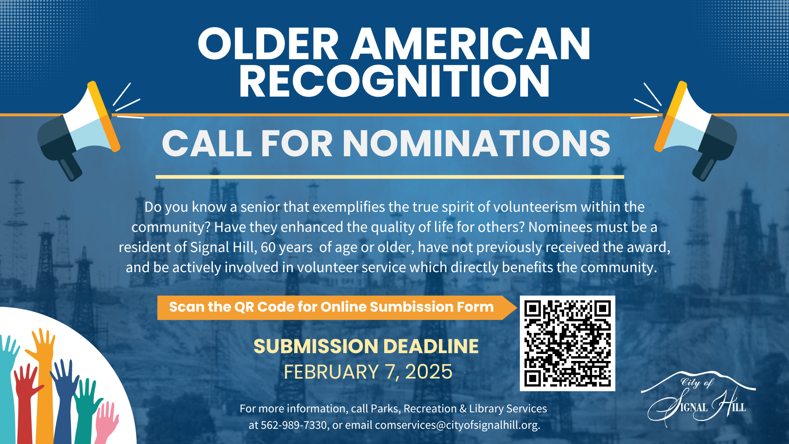
Attachment A

